**Personal Information**

Hello! My name is Zenithon Ho, but people call me Zen for short. My student number s3951225 and student e-mail is [s3951225@student.rmit.edu.au](mailto:s3951225@student.rmit.edu.au). Both my parents are from Hong Kong, but I was born in Australia. I have completed a Bachelor of Medical Imaging Science at QUT, and I am studying a Bachelor of Information Technology at RMIT, via OUA. My first language is English, followed closely by Cantonese. In my spare time, I play an online card game called Magic the Gathering: Arena, where I compete against other players whilst collecting cards. I mainly enjoy playing puzzle games, but also enjoy playing first person shooter games on my Xbox One S, such Halo: The Master Chief Collection.

**Interest in IT**

My interest in IT started when I was a very young age. I remember being absolutely fascinated by the dial-up modem when my father started up the internet connection (in the 90’s). The simple act of being connected to the world wide web and accessing information from our computer captivated me. As time progressed, and technology became more advanced, it was more difficult to keep up to the growing trends. Despite this, I am extremely keen to jump into IT, as there is always more to learn. Whether it be artificial intelligence or machine learning, having a sound knowledge in IT will help in many aspects of daily life.

At this point, I do not have any IT experience from universities. I have become drawn to programming in different languages, such as Python, JavaScript and Kotlin. My only knowledge of the languages are some small lessons done on websites such as freecodecamp.com and Codecademy. I have chosen to come to RMIT as I believe it will be the first stepping stone into a career in IT. Whilst I am interested in the programming side of IT, there are many other topics in IT that could also be beneficial to me. Through my studies at RMIT I would be expecting to learn how I would be integrating into the IT profession. Learning skills such as coding, working on projects, analysing and solving problems from the perspective of an IT professional.

**Ideal Job**

My ideal job is a position with a company called “White Bay Search” in Sydney. This position is working as a full stack developer alongside a growing ASX-listed business. This particular job is appealing to me as it would utilize my problem solving and project development skills, whilst progressing with the company. The job would allow me to continually develop my programming skills in a competitive environment, as well as delivering quality results for clients.

The qualifications and experience required for the position include: At least 2 years of being a full stack developer, with backend experience in Microsoft.Net (C#) and Typescript. Frontend experience in ReactJS using Typescript (with JavaScript also a strength). With knowledge in CSS, HTML, .NetCore and .Net5/6 experience being highly valued.

My current skills and qualifications are relatively minimal, when compared to the experience required. I have very basic knowledge in HTML, CSS, and I have a little amount of exposure to JavaScript from coding tutorials. From studying introduction to programming, I have also become exposed to some basic Python algorithms.

I plan on obtaining the skills by starting off in the backend developer route. That would require me to start off learning programming languages such as PHP, C, Python, Ruby and Java. This could be done through paid coding lessons online, or via RMIT. After becoming familiar with backend languages, I would move onto the frontend aspects. This would include strengthening my knowledge in HTML, CSS and JavaScript. This can easily be done through building a functional website as a project, to display to employers as a platform where I would showcase my experience and skills. These skills can also be learnt through free coding websites online such as freecodecamp.org or through paid options like Codecademy.

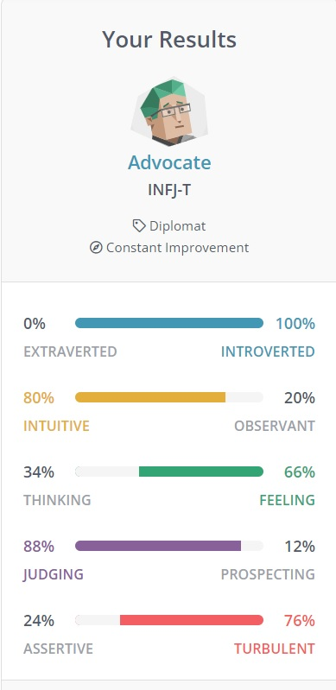**Personal Profile**

Myers-Briggs Test: Turbulent Advocate (INFJ-T)

Learning Style: Visual Learner.

Big Five Personality Test:

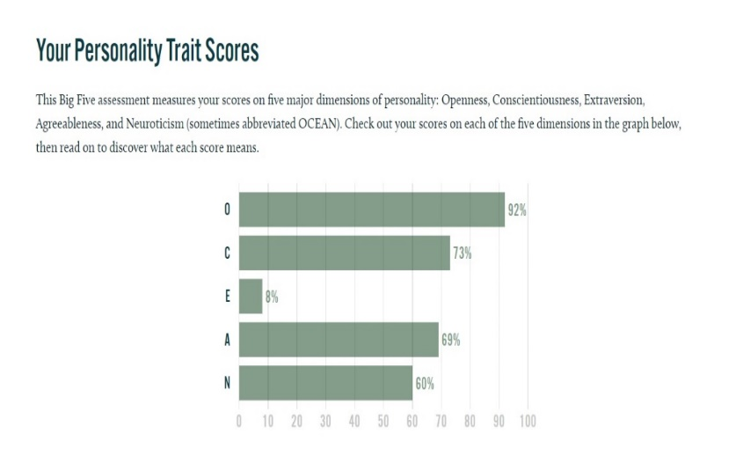**O**penness: How open I am to new experiences and ideas.

**C**onscientiousness: How organized, persistent and ambitious I am.

**E**xtraversion: How energized I am in social situations.

**A**greeableness: How much I put others before myself.

**N**euroticism: How sensitive I am when exposed to negative emotions or stress.

The result of these 1st test results shows me that I am very reserved, but I value honest relationships with others. Despite not having a large number of friends, I am more comfortable spending time with those I am familiar with. I may also focus so much on a goal that I don’t look after myself. The results also show that I don’t deal with criticism very well on an emotional level, especially when my intentions don’t align with others. The 2nd test shows that I am mainly a visual learner, and I learn best when I can visualize the material in my head. Colour stimulus and videos are also very helpful in cementing the knowledge for me. The 3rd test reinforces my 1st test in the introversion/extroversion aspect, but also shows that I am very open to new ideas and concepts. Additionally, it shows that I am ambitious, and will sometimes put others above myself.

In a team setting, my results may influence how I contribute and take feedback from others. The INFJ-T personality is a very introverted personality. They would prefer not to ask for help from others and trouble them if not necessary. As a very introverted individual, there may be an issue with the project but I don’t speak up, as to avoid unnecessary hassle. My goals may not always align with other team members, especially in a project, where everyone can have a different opinion. This could lead to an argument if I am adamant on proposing an idea or concept. INFJ-T personalities have a perfectionist mindset and are very prone to burn out. When working together on a project, the perfectionist mindset may lead to continually thinking of ways to improve something (and hence lead to more time spent), when the end result may not be ideal. In terms of learning, since I am quite visual in my learning style, it would be very helpful for me if there was a visual aid, such as a PowerPoint or Diagrams, as it would be more engaging to me.

Whilst some of these disadvantages may be detrimental when working a group, there are several ways around this. The first way is to be open to other opinions in a group, especially towards criticism. There is more than one way to reach the end result, but sometimes compromises need to be made. I should be aware of this fact, to avoid any unnecessary arguments with team members. Being introverted shouldn’t stop me from voicing ideas or opinions, as the whole point of a project is to work together towards an end goal. The perfectionist mindset does not help the group, as it creates unneeded stress and anxiety. A way around this is to adjust my standards and look at everything from the big picture. By spending less time on minute details and focusing on the important aspects of the project, this would lead to better efficiency and output in the long run.

**Project - Overview**

The project I have chosen is an application that uses machine learning to assist doctors in diagnosing COVID-19 on Chest X-rays. As Chest X-rays have always been the preliminary imaging exam for diagnosing COVID-19, the use of technology could not only predict the severity of COVID-19, but also help in the prognosis of the illness. By utilizing Convolutional Neural Networks (CNN), coupled with large datasets of Chest X-ray images, I would aim to train such an application to recognize and differentiate between a normal Chest X-ray, and someone with COVID-19. Such an application could be used in both hospital and suburban practices, allowing severe COVID-19 patients to be treated as soon as possible.

**Motivation**

Since its emergence in December 2019, COVID-19 has spread rapidly around the world. As of March 2022, the *WHO Coronavirus (COVID-19) Dashboard* estimates that there have been over 450 million confirmed cases of COVID-19, with 6 million deaths reported (World Health Organization 2022). The actual number of deaths is predicted to be much higher, due to many countries lacking means of testing and reporting. With hundreds if not thousands of hospitals at full capacity, the need for an application to assist clinicians has never been greater. Not only would it lessen the burden on the healthcare system, it would allow clinicians to provide the best level of care for patients. Sadre et al. (2021) reported on a number of Convolutional Neural Networks (CNN) that were trained for this purpose, with the highest having an accuracy of 98.75%. Whilst this is a very high percentage, it begs the question: What part of the image is causing the 1.25% of cases? This program would aim to improve on the sensitivity and specificity of diagnosing COVID-19. Problems with CNN relate to the classification of an image, especially when there is variance. This may include factors such as how a patient is positioned for a Chest X-ray, which may not be 100% perfect. By adding a large number of variations of Chest X-rays in different positions, we can use data augmentation to train the network to recognize variance. (Bhuiya 2022)

**Description**

The product will be an automated application that is installed onto the doctor’s computer. It will be a feature of an image viewing technology such as InteleViewer (*InteleViewer* 2022). The feature will aim to use machine learning, coupled with imaging databases, in order to help differentiate healthy patients from COVID-19 infected patients. The system would be used such that a Chest X-ray is inputted into the application, and the output is a prediction of whether the image represents a patient with COVID-19. It would utilize subsets of machine learning known as deep learning and CNN. To understand how the program will help clinicians in categorizing COVID-19 patients, we should start with Machine learning and Deep learning.

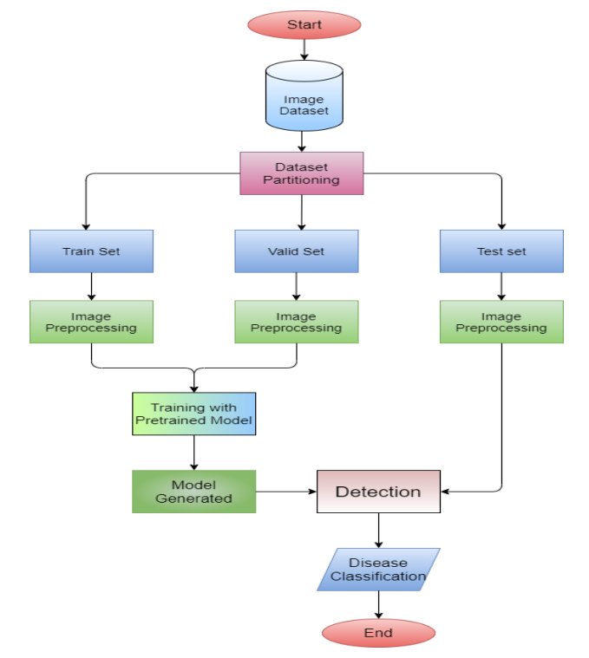Machine learning is a data science method that allows computers to gain knowledge without the need for clear rules. Algorithms are created that take advantage of large data sets, making predictions and improving with experience. Machine learning is split into 3 categories: Supervised learning, Unsupervised learning and reinforcement learning. During Supervised learning, data labels are provided to the algorithm, with expected outputs labelled by experts (i.e. Radiologists), these labels become the *Ground Truth* for such an algorithm. Ground Truth relates to data that is assumed to be true by the program. The algorithm attempts to learn a general rule that translates inputs to outputs. For the project, the program would be given images of COVID-19 patients and normal patients from a dataset, and the Radiologists would work closely with the engineers to ensure the data extracted by the machine relates to COVID-19. Unsupervised learning differs in that no data labels are given to the algorithm; its job is to figure out the hidden patterns in the data and classify them itself. Reinforcement learning interprets the consequences from multiple interactions as a learning point, being rewarded for correct actions and penalized for incorrect actions. The ideal solution would attempt to maximize the potential reward output. (Bajaj 2021) Our program would aim to use both Supervised and Unsupervised learning, with reinforcement learning as a backup. (Choy et al. 2018)

The datasets provided to the program are essential in training it. There are 3 main data sets that are used: Training, Validation and Testing. Mangeri et al. (2021) summarize how CNN are trained in Figure 1. The Training set is based on what fits the model best, as the algorithm will learn from examples. The Validation set uses different models with separate data, to adjust the model parameters at hand. Finally, the testing set is used after the algorithm is developed. This set is applied to another dataset, which will assess the accuracy, specificity and performance of the algorithm. (Cheng et al. 2021)

**Figure 1**: Flow Chart of how a CNN is trained

Source: IJACSA 2018:12:10

**What is a Convolutional Neural Networks? How does it use CNN to distinguish between a healthy patient and a COVID-19 infected patient?**

We understand how machine learning operates, but our system also uses a method known as Deep learning. Deep learning is a subgroup of Machine Learning, and is a hardware or system that is designed to think like a human brain (known as a *Neural Network*). The network can commonly contain 3 or more layers, and these layers are essential in processing our output to the user. The network allows the application to take in large amounts of data to train it, learn from its mistakes whilst improving on its accuracy as time progresses. As the algorithm is fed through a dataset, the extra neural layers assist in optimizing to a high degree of accuracy (IBM Cloud Education 2020). Models that use Deep learning are classified into 2 categories: Typical networks (that take one-dimensional inputs) or Convolutional Neural Networks (CNN) that take two- and three-dimensional inputs. (Choy et al. 2018)

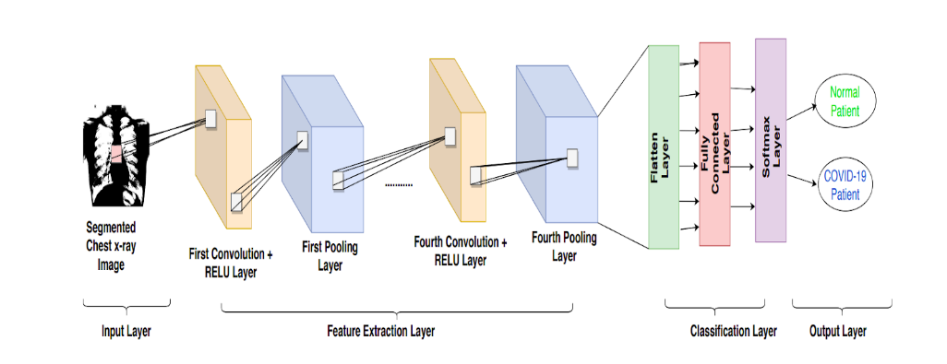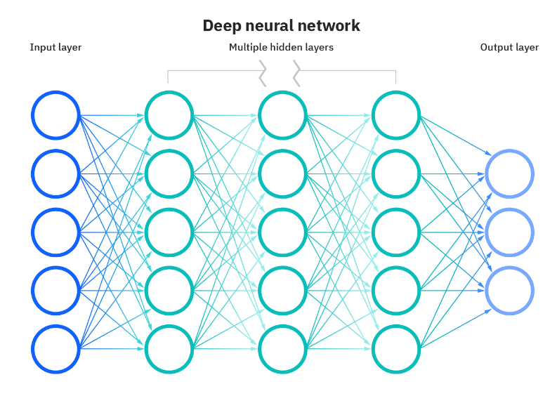For this program, a CNN is designed and would contain a set of kernels or filters (known as the convolutional layer) that compare input to matrices that encode specific features. The CNN is formed from 3 things: An input stack, an output layer, and multiple hidden layers in-between that filter the inputs to acquire useful data. Figure 2 highlights a typical CNN, produced by IBM Cloud Education (2020). These hidden layers within the CNN usually consist of an ReLU , pooling, convolutional, normalization, fully connected and a SoftMax layer. (Uddin et al. 2021) The pooling layers help increase performance output, by reducing the spatial dimensions and avoiding overfitting. A Rectified Linear Unit Layer (ReLU) is important as it ensures nonlinearity as our data progress through each subsequent layer (Low et al. 2021). The normalization layer is also used to avoid overfitting whilst maintaining a high degree of accuracy when classifying data (Rosebrock 2021). Once the data reaches the Fully Connected layer, classification of the features is performed, however, we require it to pass through the final SoftMax layer before we can produce an output. In our program, The SoftMax layer acts as a translator, it will output a percentage based on the values through the CNN. (Wood n.d.) It will predict what it believes is a COVID-19 positive patient. Figure 3 highlights a simplified CNN, starting from the input Chest X-ray image, to the output of whether a patient is COVID-19 positive or not to the user.

**Figure 3**: Process for a CNN conversion to an output

Source: Burad and Shelar, 2021. [DETECTION OF COVID-19 FROM CHEST X-RAYS USING DEEP LEARNING | Devpost](https://devpost.com/software/detection-of-covid-19-from-chest-x-rays-using-deep-learning-8ug1f3#updates)

**Figure 2**: Mapping of typical CNN

Source: IBM Cloud Education

The program would not be limited to only classifying COVID-19 patients from healthy patients. By applying a similar algorithm to a different dataset of lung images, the machine could also classify other lung pathologies such as Pneumonia or cancer.

**Tools and Technologies**

There are several open sources tools that would assist in the project; however, we would be aiming to train our CNN using TensorFlow coupled with Keras. Since training CNNs require large computational and memory resources, we would require multiple workstations with multi-core processors, rather than single-core processors. Furthermore, to effectively train the CNN dataset to distinguish between a Normal Chest X-ray and someone with COVID-19 (Or another pathology), we would require a huge dataset of Chest X-ray images, for healthy and diseased. These datasets would be accessed from publicly available websites. There is a myriad of available datasets online of Chest X-rays, “MIMIC-CXR” is one of these, a very large dataset that contains 227,835 imaging studies for 65,379 patients (Johnson et al. 2019). Another dataset that could be included is the NIH Chest X-ray dataset, with over 100,000 de-identified images of Chest X-rays (NIH Clinical Center 2017).

**Skills Required:**

As we require TensorFlow with Keras, such models would need to be implemented in Python, as Keras provides us with a Python interface. During the supervised phase of machine learning, we would require several data scientists and engineers working with radiologists. The radiologists would be required to assist in the training phase, as to give input to the engineers when the program is classifying a section of the image as COVID-19 or when it is a false positive sign. As Keras and TensorFlow are both open-source software, it would be very easy to access it for the program. However, radiologists are quite often very busy with reporting duties and interventional procedures. Hence, it may be difficult to find multiple radiologists to spend an adequate amount of time with the data scientists and engineers when developing the program.

Outcome

If the project is successful, it would help doctors in treating COVID-19 patients, whilst lessening the burden on the healthcare system. It could be used anywhere in the world, but ideally would be in countries where the healthcare system is already struggling. As COVID-19 continues to mutate and devastate health systems, the ability to instantly and accurately recognize COVID-19 infected patients would also lead to better patient prognosis. It should be noted that whilst multiple machine learning algorithms outperform human doctors when diagnosing COVID-19, several published papers have studied the processes that the machines used. They found that CNN based more of their classifications outside of the lung area, which suggested the machine was performing shortcut learning (López-Cabrera et al. 2021). Additionally, another study used images that removed the lungs on an image vs. keeping the lungs only with the CNN. It found that with the lungs removed, the CNN accuracy did not change much, but in some cases outperformed the CNN with the lungs only. (Sadre et al. 2021) This raises the question that these algorithms are using data outside of the region of interest (Lungs) when contributing to the output result. This program does not aim to replace doctors, rather, provide them a supplementary feature when triaging patients.

<https://www.seek.com.au/job/56172757?type=standout#sol=b99f863caed3ab2d0bcf77de864ff322e8e7c376>

Reference List:

WHO (World Health Organization) (2022) *WHO Coronavirus (COVID-19) Dashboard,* accessed 15 March 2021. <https://covid19.who.int/>

Sadre R, Sundaram B, Majumdar S and Ushizima D (2021) ‘Validating deep learning inference during chest X-ray classification for COVID-19 screening’, *Scientific Reports*, doi: 10.1038/s41598-021-95561-y.

Bhuiya S (2022) *Disadvantages of CNN Models*, OpenGenus IQ: Computing Expertise & Legacy website, accessed 16 March 2022. [Disadvantages of CNN models (opengenus.org)](https://iq.opengenus.org/disadvantages-of-cnn/)

*Intelerad* (2022), InteleViewer, Web-based DICOM viewer for Physicians, Intelerad website, accessed 16 March 2022. <https://www.intelerad.com/en/radiology/solutions/inteleviewer/>

Bajaj P, (2021) *Reinforcement Learning,*  GeeksforGeeks website, accessed 16 March 2022. [Reinforcement learning - GeeksforGeeks](https://www.geeksforgeeks.org/what-is-reinforcement-learning/)

Choy G, Khalilzadeh O, Michalski M, Do Synho, Samir AE, Pianykh OS, Geis JR, Pandharipande PV, Brink JA and Dreyer KJ (2018) ‘Current Applications and Future Impact of Machine Learning in Radiology’, *Radiology,* doi: 10.1148/radiol.201871820.

Cheng PM, Montagnon E, Yamashita R, Pan I, Cadrin-Chênevert A, Ing B, Romero FP, Chartrand G, Kadoury S and Tang A (2021) ‘Deep Learning: An Update for Radiologists’, *Radiographics,* doi: 10.1148/rg.2021200210.

Mangeri L, Prakasi G and Puppala N (2021) ‘Chest Diseases Prediction from X-ray Images using CNN Models: A Study’, *International Journal of Advanced Computer Science and Applications,* 12(10):3, doi: 10.14569/IJACSA.2021.0121026.

IBM Cloud Education (2020) *Deep Learning*, IBM Website, accessed 16March 2022. [What is Deep Learning? | IBM](https://www.ibm.com/cloud/learn/deep-learning)

IBM Cloud Education (2020) *Neural Networks,* IBM Website, accessed 16 March 2022. [What are Neural Networks? | IBM](https://www.ibm.com/cloud/learn/neural-networks)

IBM Cloud Education (2020) *What are Neural Networks?,* IBM Website, accessed 16 March 2022.

[What are Neural Networks? | IBM](https://www.ibm.com/cloud/learn/neural-networks)

Uddin A, Talukder B, Khan MM and Zaguia A. (2021) ‘Study on Convolutional Neural Network to Detect COVID-19 from Chest X-rays’, *Mathematical Problems in Engineering*, Volume 2021 (3366057), doi: 10.1155/2021/3366057.

Low WCS, Chuah JH, Tee CAT.H., Anis S, Shoaib MA, Faisal Amir, Khalil Azira and Lai KW. (2021) ‘An Overview of Deep Learning Techniques on Chest X-ray and CT Scan Identification of COVID-19’, *Computational and Mathematical Methods in Medicine,* Volume 2021 (5528144):3, doi: 10.1155/2021/5528144.

Rosebrock A (2021) *Convolutional Neural Networks (CNNs) and Layer Types*, pyimagesearch website, accessed 16 March 2022. [Convolutional Neural Networks (CNNs) and Layer Types - PyImageSearch](https://pyimagesearch.com/2021/05/14/convolutional-neural-networks-cnns-and-layer-types/)

Wood T (n.d.) *What is the Softmax Function?*, DeepAI website, accessed 16 March 2022. [Softmax Function Definition | DeepAI](https://deepai.org/machine-learning-glossary-and-terms/softmax-layer)

Burad P and Shelar J, *Detection of COVID-19 from Chest X-rays Using Deep Learning,* Devpost website, accessed 16 March 2022. [DETECTION OF COVID-19 FROM CHEST X-RAYS USING DEEP LEARNING | Devpost](https://devpost.com/software/detection-of-covid-19-from-chest-x-rays-using-deep-learning-8ug1f3#updates)

Johnson AEW, Pollard TJ, Berkowitz SJ, Greenbaum NR, Lungren MP, Deng C-Y, Mark RG and Horng S. (2019) ‘MIMIC-CXR, a de-identified publicly available database of chest radiographs with free-text reports’, *Scientific Data,* 6:317, doi: 10.1038/s41597-019-0322-0.

Wang X, Peng Y, Lu L, Lu Z, Bagheri M and Summers R. (2017) *Hospital-scale Chest X-ray Database and Benchmarks on Weakly-Supervised Classification and Localization of Common Thorax Diseases, NIH Clinical Center,* accessed 17 March 2022. <https://nihcc.app.box.com/v/ChestXray-NIHCC>

López-Cabrera JD, Orozco-Morales R, Portal-Díaz JA, Lovelle-Enríquez O and [Pérez-Díaz](https://link.springer.com/article/10.1007/s12553-021-00609-8#auth-Marl_n-P_rez_D_az) M. (2021) *Current limitations to identify covid-19 using artificial intelligence with chest x-ray imaging (part ii). The shortcut learning problem,* *Health and Technology*, Volume 11 (1331-1345), doi: 10.1007/s12553-021-00609-8.